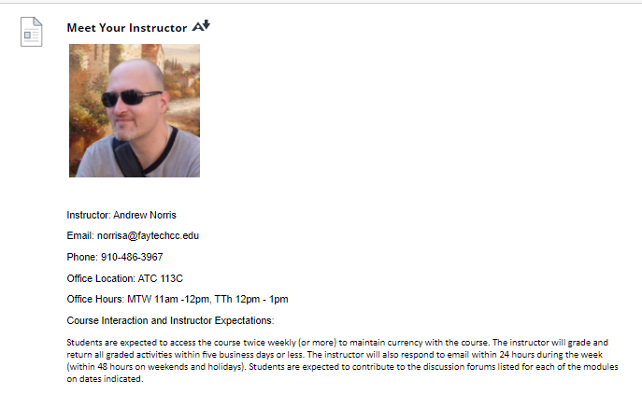

**Meet Your Instructor**

[Meet Your Instructor](https://faytechcc.blackboard.com/webapps/blackboard/content/listContent.jsp?course_id=_35059_1&content_id=_5950053_1&mode=reset)

Instructor: Andrew Norris

Email: norrisa@faytechcc.edu

Phone: 910-486-3967

Office Location: ATC 113C

Office Hours: MTW 11am -12pm, TTh 12pm - 1pm

Course Interaction and Instructor Expectations:

Students are expected to access the course twice weekly (or more) to maintain currency with the course. The instructor will grade and return all graded activities within five business days or less. The instructor will also respond to email within 24 hours during the week (within 48 hours on weekends and holidays). Students are expected to contribute to the discussion forums listed for each of the modules on dates indicated.